Discussion draft

# Conclusions and future research directions

This thesis provides new insights into the role of rodent ecology on LASV transmission and subsequent spillover into human populations in Sierra Leone through examining the association of anthropogenic land use change with rodent community structure. The methods used in this thesis to address the research questions included a literature review and synthesis of publicly available data from rodent trapping studies across West Africa and primary data collection through systematic rodent trapping in a Lassa fever endemic region of Eastern Sierra Leone. This final chapter summarises the key findings from the thesis and reflects on the general strengths and limitations of the work, with more detailed issues pertaining to each study covered at the end of each chapter. The final sections of this chapter focus on the implications of the work conducted for the understanding of Lassa fever epidemiology and provide suggestions for future research.

## Principle findings of the thesis

Limited primary data from rodent trapping studies conducted in Sierra Leone hinders our understanding of the Lassa fever disease system (Monath et al. 1974; McCormick et al. 1987; Mahy 1992; Barnett et al. 2000; Leski et al. 2015; Bangura et al. 2021). Few comprehensive rodent ecological studies have been designed to investigate the role of the broader rodent community in LASV transmission (Demby et al. 2001; Fichet-Calvet et al. 2005; Mariën et al. 2018; Mariën et al. 2020). Much of the available data come from opportunistic sampling of rodents following Lassa fever outbreaks in human communities (Monath et al. 1974; Wulff, Fabiyi, and Monath 1975; Safronetz et al. 2010; Yadouleton et al. 2019; Happi et al. 2022). Therefore, Chapter 2 set out to conduct a scoping review and quantitative synthesis of existing trapping studies to assess the current state of rodent and rodent-associated pathogen sampling across West Africa. The data from the included studies were compiled into a database, made available for reuse by the scientific and public health community (Simons 2022c). The scoping review found that primary rodent trapping studies are needed to effectively complement existing datasets (i.e., IUCN and GBIF) by expanding the geographic areas sampled. It also identified regions and host-pathogen associations that have been relatively under-sampled, thus limiting the inference that can be drawn from available datasets. Furthermore, the developed measure of relative sampling bias generated as part of the scoping review in Chapter 2 can be used to adjust for spatial and taxonomic biases in future dynamical systems models, improving the prediction of zoonotic infectious disease emergence risk.

The findings from Chapter 2 and the previous literature indicate that multiple rodent host species likely contribute to LASV transmission and maintenance among rodent populations (Wulff, Fabiyi, and Monath 1975; Demby et al. 2001; Fichet-Calvet et al. 2014; Olayemi et al. 2016; Yadouleton et al. 2019). However, data remain limited regarding the structure of these rodent populations within multi-species communities, particularly with regards to how the structure of these communities may change across anthropogenic land use gradients. To address this knowledge gap, a three-year rodent trapping study was designed and implemented in a Lassa fever endemic region of Eastern Sierra Leone. This longitudinal study aimed to sample rodent communities across a land use gradient ranging from natural forest settings to agriculture areas and human habitation, with a view to characterise the rodent communities within these habitats. Sampling was conducted at a high temporal resolution to account for expected seasonal dynamics in rodent occupancy and abundance. The findings from the longitudinal study were presented in Chapters 3 and 4, summarised below.

Chapter 3 found that the primary host of LASV (*M. natalensis*) had a high probability of occurrence in areas of human habitation and agricultural settings, while being effectively absent from less anthropogenically disturbed forest habitats. However, in locations of high human population density, this species was found to occur at much lower rates than previously expected. If occurrence of *M. natalensis* generates the greatest risk of subsequent human infection with LASV (as suggested by available evidence prior to this study), the risk of LASV spillover from rodent communities would be expected to increase along an anthropogenic gradient from forest to villages (Bonwitt et al. 2017). However, as indicated by the findings in Chapter 3, the magnitude of this risk may be substantially reduced in highly urbanised settings due to the low prevalence of the primary rodent host species. Furthermore, important biotic interactions between species were observed within the rodent communities. For example, the presence of an invasive rodent species (*M. musculus*), exclusively detected in areas with high human population density, exhibited a negative association with the occurrence of *M. natalensis* and other native rodent species. In contrast, the association between another invasive rodent (*R. rattus*) and native rodent species showed common co-occurrence patterns. As proposed by other researchers (Lippens et al. 2017), these findings may be interpreted to suggest that the ongoing range expansion of these invasive species in West Africa will lead to biotic interactions that could influence the distribution of native rodent species across the region. While there is some evidence of LASV infection in both *M. musculus* and *R. rattus*, the contribution to onward transmission among rodents by these two species is currently unknown but expected to be minimal compared with *M. natalensis* (Demby et al. 2001). Therefore, potential changes in rodent community structure due to land use changes and invasive species range expansion are likely to alter LASV pathogen dynamics within the endemic region and have important implications for the risk of Lassa fever outbreaks.

Chapter 4 highlights the heterogenous contact rates within rodent communities in Sierra Leone, which has an impact on pathogen transmission. The analysis showed that rodent contact networks across the anthropogenic land use gradient exhibit characteristics of sparse networks, with a similar number of contacts for each individual rodent. However, there is significant heterogeneity in network structure within and between land use types. Specifically, *M. natalensis* was found to have a higher likelihood of forming intra-specific contacts compared with inter-specific contacts. These differential contact rates could promote pathogen transmission if other species were to be less competent hosts (Luis, Kuenzi, and Mills 2018). Intra-specific contacts among *M. natalensis* were more prevalent within agricultural settings than in areas of human habitation, suggesting that while human infection primarily occurs in human habitation settings, transmission among rodent populations may predominantly occur in agricultural settings. This finding could have important implications for public health interventions aiming to control the transmission of LASV among rodent populations if rodent control is solely focused on villages. Lastly, Chapter 4 found lower than expected prevalence of antibodies to LASV in the sampled rodent communities within an area of Sierra Leone considered a highly endemic area for Lassa fever. A total of 684 rodents were trapped over 43,266 trap nights, resulting in a prevalence of antibodies to LASV of 3.3%. This is substantially lower than has been detected elsewhere in the region (e.g., up to 67% in Guinea and 76% in Nigeria), although it must be noted that the methodologies of these studies varied greatly (Fichet-Calvet et al. 2007; Adesina et al. 2023). Previous studies in Sierra Leone and Nigeria have typically relied on opportunistic trapping of rodents in locations during a known outbreak (Monath et al. 1974; Wulff, Fabiyi, and Monath 1975; Happi et al. 2022). In contrast, longer term studies in Guinea have found high rodent seroprevalence in locations that do not typically report human Lassa fever cases (Fichet-Calvet et al. 2007). Therefore, the findings from Chapter 4 underscore the challenges in understanding the complex interplay between rodent and pathogen ecology. The low levels of LASV observed in the present study are likely indicative of multi-year cycles of pathogen transmission. If this study were conducted over a substantially longer time period (i.e., several years), periods of elevated LASV transmission among the rodent community would likely be observed.

## General strengths and limitations

This thesis has several strengths. First, the adoption of Open Science practices constitutes a key strength (Foster and Deardorff 2017; Powers and Hampton 2019). Throughout this thesis, I have produced and archived study protocols, data collection tools, raw and processed data, pre-processing and analytic code and pre-printed manuscripts on Open Science platforms (e.g., GitHub). Taking this approach will allow researchers to obtain the information that matters to them from my research outputs and build onto these, thus limiting research waste and facilitating scientific progress (Simons 2023). For example, to support re-use of the dataset in Chapter 2, I produced an accompanying web-based application to allow researchers to visualise the processed data and associated meta-data with the aim of promoting uptake of this novel datasource (Simons 2022a). In addition, the rodent trapping data presented in Chapters 3 and 4 have been deposited on the Pathogen Harmonised Surveillance (PHAROS) database, an open-access repository produced by the Verena Institute. This will allow researchers to re-use the data while the manuscripts generated from Chapters 3 and 4 proceed through the peer-review process (The Verena Institute 2023).

Second, a methodological strength of this thesis is the systematic approach taken to sampling rodents across a land use gradient. The design of the rodent trapping study presented in Chapters 3 and 4 was selected to limit the impact of known sampling biases on inference of habitat occupancy by rodent species within diverse communities. The approach taken within this thesis will be of use to other rodent ecology researchers, particularly those conducting rodent-associated disease research in West Africa. The adoption of the study protocol and data collection tools by other researchers interested in similar questions can improve harmonisation of study designs, thus supporting meta-analysis of rodent ecology studies across geographic regions. To raise awareness of the availability of these study protocols and tools, I have presented the study design and results from Chapters 3 and 4 at scientific workshops and conferences within the field of disease ecology and beyond.

Third, the work in this thesis benefited from strong integration within the communities in which the research was conducted. Throughout the study design and implementation stages, informal consultations were conducted with local researchers and village communities within Eastern Sierra Leone. These consultations guided the selection of research questions, study design (e.g., the selection of trap sites) and data collection methods (e.g., paper-and-pen questionnaires in addition to photos taken on smartphones), incorporating valuable local knowledge. Study protocols were piloted within the village communities and revised following input from field workers and community members to improve acceptability and accuracy of data collection. The success of the rodent trapping study would not have been possible without the strong support received from our local collaborators. This thesis highlights the importance of integrating local knowledge early in the research process.

Finally, throughout the research process, I was able to directly contribute to the training and development of local researchers in Sierra Leone. The training sessions on rodent trapping, sampling and laboratory analysis led me to reconsider the role of training and development within international collaborations. The existing skills of local researchers are not always acknowledged and training as part of individual projects do not appear to promote sustainable career progression by supporting researchers to advance beyond technical competence. Local researchers would benefit from support to develop into independent scientists. To support my collaborators develop the qualifications required to attract research funds, I have assisted in acquiring individual funding to enrol in higher education degrees at international universities.

Several general limitations of the thesis are also important to highlight. First, the thesis had a narrow geographic scope and the applicability of my findings on the structure of rodent communities and the interactions between them may not apply to the wider endemic region of Lassa fever. More work is required to replicate the longitudinal trapping study in other regions of Sierra Leone and within West Africa to assess whether these are local effects or if the findings are replicable across geographic scales.

A second important limitation is the method of trapping used. In designing the rodent trapping study, I balanced the need to obtain unbiased estimates of rodent occurrence with the requirement to be able to construct space sharing interactions between individual rodents. To achieve this, I adopted a grid-based approach with trapping occurring in four-night sessions. Other researchers have adopted line- and web-based trapping, which are able to survey a greater area but would introduce difficulties in assessing space sharing []. The number of trap-nights required to adequately sample a habitat is also not known, with individual researchers adopting different numbers based on funding availability, timelines and the expected behaviour of local rodent populations. Whether my decision to adopt grid-based trapping or to trap for four nights may have biased the obtained data is difficult to assess without comparable studies in Sierra Leone.

Finally, I did not assess for acute infection with LASV in the samples obtained from the rodent trapping study. The primary reason for this was the low expected yield of positive results. Unpublished research from a rodent trapping study conducted in Eastern Sierra Leone suggested an incidence of acute infection of ~1% (Moses, L. personal communication). This prevalence estimate matches with data showing an incidence of 0.3% in the same region (ref). A second reason was lack of financial resources available to perform viral PCR alongside serology; therefore, serology only was prioritised. Samples have been stored in conditions that would allow subsequent investigation for acute LASV infection and I am currently exploring collaborations that would allow this.

## Implications for Lassa fever epidemiology and future research directions

Current dynamic risk models of Lassa fever are limited by the spatial and temporal biases in the sampling of rodent, pathogen and human populations. Figure @ref(fig:model-outputs) shows the outputs from four models of Lassa fever risk in human populations based on contemporaneously available data (Fichet-Calvet and Rogers 2009; Mylne et al. 2015; Redding et al. 2016; Basinski et al. 2021). While these approaches modelled slightly different outcomes (i.e., predicted risk, predicted zoonotic niche, number of spillover events and number of infections), findings were generally consistent with observed human case data indicating that the risk of Lassa fever is concentrated in two geographic clusters of Guinea, Liberia and Sierra Leone (cluster 1) and Nigeria (cluster 2). The increased risk in Nigeria compared with the Western cluster is due to the comparatively high density of human populations in Nigeria leading to both an increased number of spillover events and number of infections. However, these risk maps do not consistently match with reported human epidemiology. A recent illustrative example from an outbreak of Lassa fever in Accra, Ghana, identified 14 acute cases in February 2023 in a region not previously considered endemic and considered at low risk by most of the spatial models of Lassa fever risk (Ghana Health Services 2023). In addition, case numbers reported from the Western cluster are substantially lower than expected from these models (Simons 2022b). ,rodent sampling parameterization, ultimately helping. Thisfurther

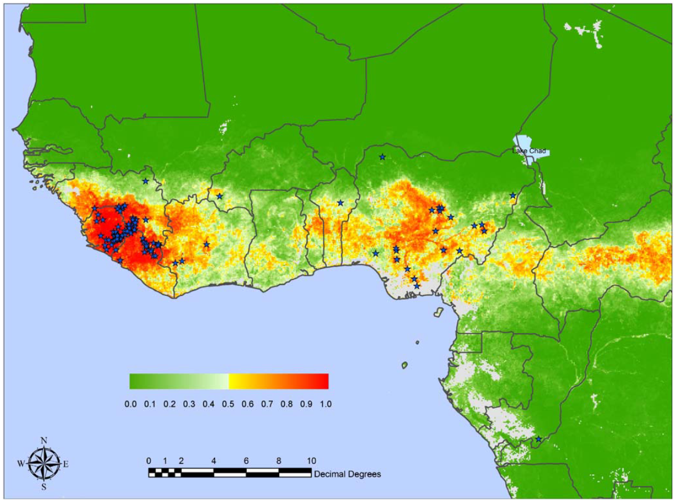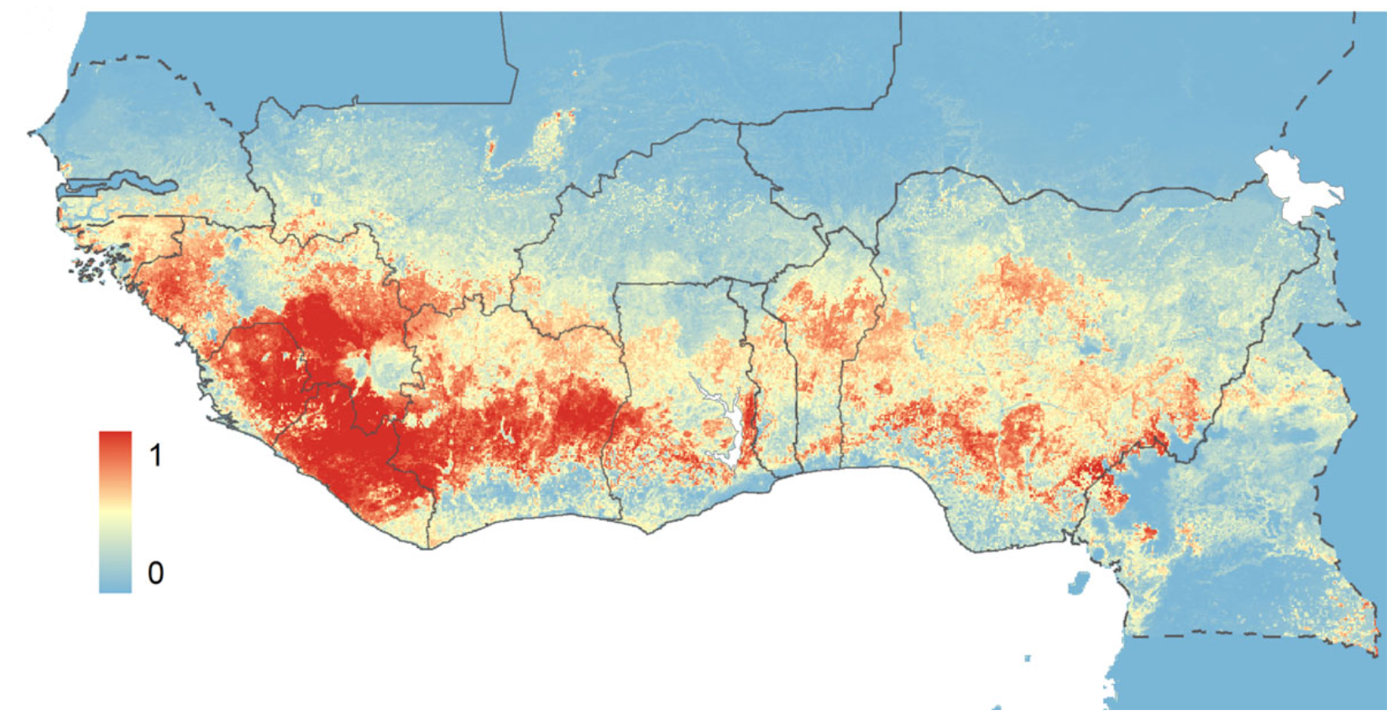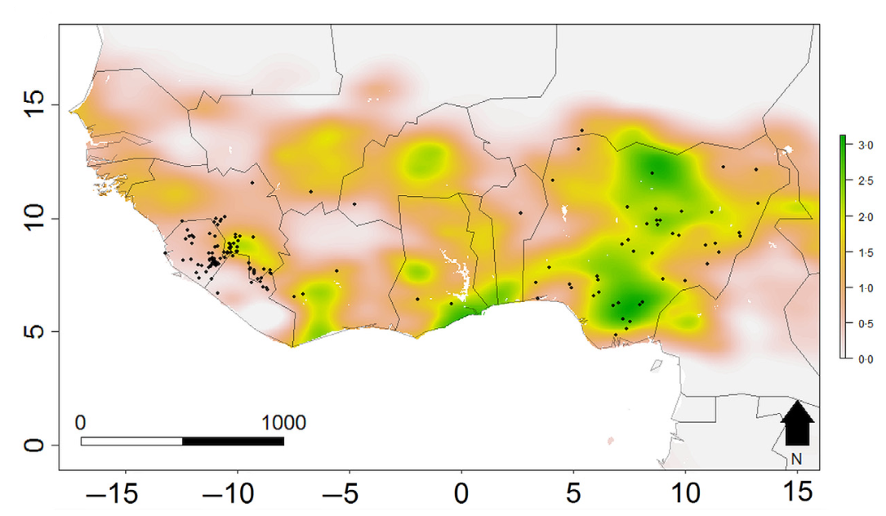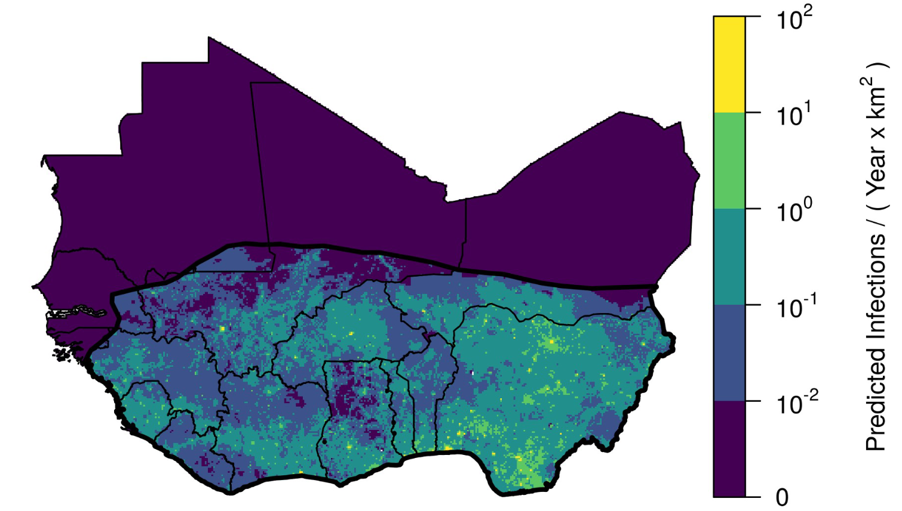

The rodent trapping study conducted as part of this thesis has highlighted the need for long-term rodent surveys in the Lassa fever endemic region. To understand the risk to human communities from Lassa fever spillover, there is a need for unbiased data on the multi-year dynamics of LASV prevalence within rodent communities. Previous studies have shown substantial asynchrony in rodent and human infection. For example, a low prevalence of rodent infection has been found in the context of high human seroprevalence or incidence of infection, suggesting a temporal lag (Lukashevich, Clegg, and Sidibe 1993; Demby et al. 2001). In contrast, some studies have identified substantial transmission among rodent populations but few human cases of Lassa fever (Fichet-Calvet et al. 2005, 2007). Combining LASV, rodent and human studies over longer time scales (i.e., several years) at high sampling frequency (i.e., monthly) will help to elucidate whether these previous observations have been driven by biased geographic and temporal sampling or whether these trends are driven by underlying dynamics and temporal lags within the host-pathogen system. This study design would require significant resources and have not yet been performed.

Further, the dynamic interplay between pathogen, rodent and human factors driving Lassa fever spillover events occurs across different time scales. At the rapid end of the time scale is the infectious period of LASV in individual rodents (1-2 months) and rodent life expectancy (<1 year), while the protracted end of the spectrum includes changes in rodent community structure due to land use change or invasive species (decades) and human longevity (i.e., life expectancy in Sierra Leone is 60 years) (Leirs, Verhagen, and Verheyen 1993; Wells, Lakim, and O’Hara 2014; Dalecky et al. 2015; Safronetz et al. 2022; World Health Organisation 2023). The age at which humans are infected with LASV is also thought to be associated with the severity of disease and is expected to lead to long-term immunity (Duvignaud et al. 2021; Strampe et al. 2021; Garry 2023). In addition, the force-of-infection from rodent to human populations will dictate the age-stratified infection risk in humans (Davis and Calvet 2005; Arthur et al. 2017). For example, in the study system sampled as part of this thesis, the low prevalence of LASV antibodies suggests minimal transmission within the rodent population and therefore the annual probability of a human being infected in these setting is likely low. This is expected to lead to human infections occurring in older age groups, with these individuals developing more severe disease. However, our study also shows that most of the rodents remain susceptible to infection which, were they to be exposed to LASV, would promote LASV transmission and an outbreak within rodent populations, which could shift the risk of infection in humans to younger age groups who are expected to develop less severe disease. Therefore, similar to the suggestion in the above paragraph, multi-year studies of LASV and rodents would be beneficial to understand these complex dynamics.

Finally, there is an increasing drive for data consolidation to support “big data” approaches to zoonotic infectious disease risk prediction and preparedness (Carlson et al. 2021). These approaches typically consolidate data from multiple studies or public repositories of data and often span disciplinary boundaries (Garine-Wichatitsky et al. 2022). The increasing availability of repositories (e.g., GBIF) for raw and processed data should be embraced by the research community to accelerate the volume of data that are available for analysis. This ought to be balanced with appropriate attribution for researchers involved in the primary data collection (Bahlai et al. 2019; @ Carlson et al. 2021). Importantly, the data must be shared with adequate meta-data to support appropriate secondary analyses. As discussed above, the development and adoption of protocol harmonisation and reporting standards of rodent and pathogen sampling studies is needed and would help ensure that important meta-data are available, as has been adopted in several biomedical disciplines (i.e., CONSORT) (Schulz et al. 2010). Improving reporting standards also supports the adoption of risk-of-bias tools (e.g., “Risk-Of-Bias In studies of Temporal Trends in ecology” (ROBITT)), which facilitates the adjustment for geographic, temporal and sampling biases within the contributing datasets (Navarro et al. 2021; Boyd et al. 2022).

## Concluding remarks

A greater understanding of rodent community ecology is required to design public health interventions against Lassa fever in endemic regions. This thesis aimed to gain a better understanding of how rodent communities are structured along anthropogenic land use gradients, with a view to informing interpretation of human Lassa fever epidemiology. This was achieved through a scoping review and synthesis of published rodent trapping studies across West Africa and primary data collection through a three-year rodent trapping study. Current biases in sampling of rodent hosts and their pathogens across West Africa limit the inference able to be drawn from available data on the current and future risks of zoonotic disease emergence. Results from the rodent trapping survey characterised the structure of rodent communities within the Lassa fever endemic region of Eastern Sierra Leone and informed the contact networks pathogens such as LASV will transmit through. These findings can be used to inform the design of combined rodent and human epidemiological studies of Lassa fever and to guide the development of public health interventions.

Adesina, Adetunji Samuel, Akinlabi Oyeyiola, Adeoba Obadare, Joseph Igbokwe, Chukwuyem Abejegah, Patience Akhilomen, Umaru Bangura, et al. 2023. “Circulation of Lassa Virus Across the Endemic Edo-Ondo Axis, Nigeria, with Cross-Species Transmission Between Multimammate Mice.” *Emerging Microbes & Infections* 12 (1): 2219350. <https://doi.org/10.1080/22221751.2023.2219350>.

Arthur, Ronan F., Emily S. Gurley, Henrik Salje, Laura S. P. Bloomfield, and James H. Jones. 2017. “Contact Structure, Mobility, Environmental Impact and Behaviour: The Importance of Social Forces to Infectious Disease Dynamics and Disease Ecology.” *Philosophical Transactions of the Royal Society B: Biological Sciences* 372 (1719): 20160454. <https://doi.org/10.1098/rstb.2016.0454>.

Bahlai, Christie A., Lewis J. Bartlett, Kevin R. Burgio, Auriel M. V. Fournier, Carl N. Keiser, Timothee Poisot, and Kaitlin Stack Whitney. 2019. “Open Science Isn’t Always Open to All Scientists: Current Efforts to Make Research More Accessible and Transparent Can Reinforce Inequality Within STEM Professions.” *American Scientist* 107 (2): 78–83. <https://doi.org/10.1511/2019.107.2.78>.

Bangura, Umaru, Jacob Buanie, Joyce Lamin, Christopher Davis, Gedeon Ngiala Bongo, Michael Dawson, Rashid Ansumana, et al. 2021. “Lassa Virus Circulation in Small Mammal Populations in Bo District, Sierra Leone.” *BIOLOGY-BASEL* 10 (1). <https://doi.org/10.3390/biology10010028>.

Barnett, Adrian Ashton, Nicholas Read, Jonathan Scurlock, Christopher Low, Hugh Norris, and Rebecca Shapley. 2000. “Ecology of Rodent Communities in Agricultural Habitats in Eastern Sierra Leone: Cocoa Groves as Forest Refugia.” *Tropical Ecology*, 17. <http://www.tropecol.com/pdf/open/PDF_41_2/kp41201.pdf>.

Basinski, Andrew J., Elisabeth Fichet-Calvet, Anna R. Sjodin, Tanner J. Varrelman, Christopher H. Remien, Nathan C. Layman, Brian H. Bird, et al. 2021. “Bridging the Gap: Using Reservoir Ecology and Human Serosurveys to Estimate Lassa Virus Spillover in West Africa.” Edited by Amy Wesolowski. *PLOS Computational Biology* 17 (3): e1008811. <https://doi.org/10.1371/journal.pcbi.1008811>.

Bonwitt, Jesse, Almudena Mari Sáez, Joseph Lamin, Rashid Ansumana, Michael Dawson, Jacob Buanie, Joyce Lamin, et al. 2017. “At Home with Mastomys and Rattus: Human-Rodent Interactions and Potential for Primary Transmission of Lassa Virus in Domestic Spaces.” *The American Journal of Tropical Medicine and Hygiene* 96 (4): 935–43. <https://doi.org/10.4269/ajtmh.16-0675>.

Boyd, Robin J., Gary D. Powney, Fiona Burns, Alain Danet, François Duchenne, Matthew J. Grainger, Susan G. Jarvis, et al. 2022. “ROBITT: A Tool for Assessing the Risk-of-Bias in Studies of Temporal Trends in Ecology.” *Methods in Ecology and Evolution* 13 (7): 1497–507. <https://doi.org/10.1111/2041-210X.13857>.

Carlson, Colin J., Maxwell J. Farrell, Zoe Grange, Barbara A. Han, Nardus Mollentze, Alexandra L. Phelan, Angela L. Rasmussen, et al. 2021. “The Future of Zoonotic Risk Prediction.” *Philosophical Transactions of the Royal Society B: Biological Sciences* 376 (1837): 20200358. <https://doi.org/10.1098/rstb.2020.0358>.

Dalecky, Ambroise, Khalilou Ba, Sylvain Piry, Cedric Lippens, Christophe A. Diagne, Mamadou Kane, Aliou Sow, et al. 2015. “Range Expansion of the Invasive House Mouse Mus Musculus Domesticus in Senegal, West Africa: A Synthesis of Trapping Data over Three Decades, 1983-2014.” *Mammal Review* 45 (3): 176–90. <https://doi.org/10.1111/mam.12043>.

Davis, Stephen, and E Calvet. 2005. “Fluctuating Rodent Populations and Risk to Humans from Rodent-Borne Zoonoses.” *Vector-Borne & Zoonotic Diseases* 5 (4): 305–14. <https://doi.org/10.1089/vbz.2005.5.305>.

Demby, Austin H., Alphonse Inapogui, Kandeh Kargbo, James Koninga, Kerfalla Kourouma, James Kanu, Mamadi Coulibaly, et al. 2001. “Lassa Fever in Guinea: II. Distribution and Prevalence of Lassa Virus Infection in Small Mammals.” *Vector-Borne and Zoonotic Diseases* 1 (4): 283–97. <https://doi.org/10.1089/15303660160025912>.

Duvignaud, Alexandre, Marie Jaspard, Ijeoma Chukwudumebi Etafo, Delphine Gabillard, Béatrice Serra, Chukwuyem Abejegah, Camille le Gal, et al. 2021. “Lassa Fever Outcomes and Prognostic Factors in Nigeria (LASCOPE): A Prospective Cohort Study.” *The Lancet Global Health* 9 (4): e469–78. <https://doi.org/10.1016/S2214-109X(20)30518-0>.

Fichet-Calvet, Elisabeth, Beate Becker-Ziaja, Lamine Koivogui, and Stephan Günther. 2014. “Lassa Serology in Natural Populations of Rodents and Horizontal Transmission.” *Vector Borne and Zoonotic Diseases* 14 (9): 665–74. <https://doi.org/10.1089/vbz.2013.1484>.

Fichet-Calvet, Elisabeth, Kekoura Koulemou, Lamine Koivogui, Barre Soropogui, Oumar Sylla, Emilie Lecompte, Stephane Daffis, et al. 2005. “Spatial Distribution of Commensal Rodents in Regions with High and Low Lassa Fever Prevalence in Guinea.” *Belgian Journal of Zoology* 135 (December): 63–67. <https://biblio.naturalsciences.be/associated_publications/bjz/bibliographic-references/ISI_000203706900011>.

Fichet-Calvet, Elisabeth, Emilie Lecompte, Lamine Koivogui, Barré Soropogui, Amadou Doré, Fodé Kourouma, Oumar Sylla, Stéphane Daffis, Kékoura Koulémou, and Jan Ter Meulen. 2007. “Fluctuation of Abundance and Lassa Virus Prevalence in Mastomys Natalensis in Guinea, West Africa.” *Vector Borne and Zoonotic Diseases* 7 (2): 119–28. <https://doi.org/10.1089/vbz.2006.0520>.

Fichet-Calvet, Elisabeth, and David John Rogers. 2009. “Risk Maps of Lassa Fever in West Africa.” *PLOS Neglected Tropical Diseases* 3 (3): e388. <https://doi.org/10.1371/journal.pntd.0000388>.

Foster, Erin D., and Ariel Deardorff. 2017. “Open Science Framework (OSF).” *Journal of the Medical Library Association : JMLA* 105 (2): 203–6. <https://doi.org/10.5195/jmla.2017.88>.

Garine-Wichatitsky, Michel de, Olivia Wesula Lwande, Nicholas M. Fountain-Jones, Kim VanderWaal, and Vincent Obanda. 2022. “Editorial: Disease Ecology: Novel Concepts and Methods to Track and Forecast Disease Emergence, Transmission, Spread, and Endemization.” *Frontiers in Ecology and Evolution* 10. <https://doi.org/10.3389/fevo.2022.890510>.

Garry, Robert F. 2023. “Lassa Fever — the Road Ahead.” *Nature Reviews Microbiology* 21 (2): 87–96. <https://doi.org/10.1038/s41579-022-00789-8>.

Ghana Health Services. 2023. “Lassa Fever Press Release Ghana 2023,” April. <https://osf.io/ft2gy/>.

Happi, Anise N., Testimony J. Olumade, Olusola A. Ogunsanya, Ayotunde E. Sijuwola, Seto C. Ogunleye, Judith U. Oguzie, Cecilia Nwofoke, et al. 2022. “Increased Prevalence of Lassa Fever Virus-Positive Rodents and Diversity of Infected Species Found During Human Lassa Fever Epidemics in Nigeria.” *Microbiology Spectrum* 10 (4): e0036622. <https://doi.org/10.1128/spectrum.00366-22>.

Johnson, Erica E., Luis E. Escobar, and Carlos Zambrana-Torrelio. 2019. “An Ecological Framework for Modeling the Geography of Disease Transmission.” *Trends in Ecology & Evolution* 34 (7): 655–68. <https://doi.org/10.1016/j.tree.2019.03.004>.

Leirs, Herwig, Ron Verhagen, and Walter Verheyen. 1993. “Productivity of Different Generations in a Population of Mastomys Natalensis Rats in Tanzania.” *Oikos* 68 (1): 53–60. <https://doi.org/10.2307/3545308>.

Leski, Tomasz A, Michael G Stockelman, Lina M Moses, Matthew Park, David A Stenger, Rashid Ansumana, Daniel G Bausch, and Baochuan Lin. 2015. “Sequence Variability and Geographic Distribution of Lassa Virus, Sierra Leone.” *Emerging Infectious Diseases* 21 (4): 609–18. <https://doi.org/10.3201/eid2104.141469>.

Lippens, C., A. Estoup, M. K. Hima, A. Loiseau, C. Tatard, A. Dalecky, K. Ba, et al. 2017. “Genetic Structure and Invasion History of the House Mouse (Mus Musculus Domesticus) in Senegal, West Africa: A Legacy of Colonial and Contemporary Times.” *Heredity* 119 (2): 64–75. <https://doi.org/10.1038/hdy.2017.18>.

Luis, Angela D., Amy J. Kuenzi, and James N. Mills. 2018. “Species Diversity Concurrently Dilutes and Amplifies Transmission in a Zoonotic Host–Pathogen System Through Competing Mechanisms.” *Proceedings of the National Academy of Sciences* 115 (31): 7979–84. <https://doi.org/10.1073/pnas.1807106115>.

Lukashevich, I. S., J. C. Clegg, and K. Sidibe. 1993. “Lassa Virus Activity in Guinea: Distribution of Human Antiviral Antibody Defined Using Enzyme-Linked Immunosorbent Assay with Recombinant Antigen.” *Journal of Medical Virology* 40 (3): 210–17. <https://doi.org/10.1002/jmv.1890400308>.

Mahy, Brian. 1992. “Maintenance Support of a Field Station in Sierra Leone, West Africa.” U.S. ARMY MEDICAL RESEARCH AND DEVELOPMENT COMMAND. <https://doi.org/ADA254536>.

Mariën, Joachim, Giovanni Lo Iacono, Toni Rieger, Nfaly Magassouba, Stephan Günther, and Elisabeth Fichet-Calvet. 2020. “Households as Hotspots of Lassa Fever? Assessing the Spatial Distribution of Lassa Virus-Infected Rodents in Rural Villages of Guinea.” *Emerging Microbes & Infections* 9 (1): 1055–64. <https://doi.org/10.1080/22221751.2020.1766381>.

Mariën, Joachim, Fodé Kourouma, N’Faly Magassouba, Herwig Leirs, and Elisabeth Fichet-Calvet. 2018. “Movement Patterns of Small Rodents in Lassa Fever-Endemic Villages in Guinea.” *EcoHealth* 15 (2): 348–59. <https://doi.org/10.1007/s10393-018-1331-8>.

McCormick, J B, P A Webb, J W Krebs, K M Johnson, and E S Smith. 1987. “A Prospective Study of the Epidemiology and Ecology of Lassa Fever.” *The Journal of Infectious Diseases* 155 (3): 437–44. <https://doi.org/10.1093/infdis/155.3.437>.

Monath, T. P., V. F. Newhouse, G. E. Kemp, H. W. Setzer, and A. Cacciapuoti. 1974. “Lassa Virus Isolation from Mastomys Natalensis Rodents During an Epidemic in Sierra Leone.” *Science* 185 (4147): 263–65. <https://doi.org/10.1126/science.185.4147.263>.

Mylne, Adrian Q. N., David M. Pigott, Joshua Longbottom, Freya Shearer, Kirsten A. Duda, Jane P. Messina, Daniel J. Weiss, Catherine L. Moyes, Nick Golding, and Simon I. Hay. 2015. “Mapping the Zoonotic Niche of Lassa Fever in Africa.” *Transactions of The Royal Society of Tropical Medicine and Hygiene* 109 (8): 483–92. <https://doi.org/10.1093/trstmh/trv047>.

Navarro, Constanza L. Andaur, Johanna A. A. Damen, Toshihiko Takada, Steven W. J. Nijman, Paula Dhiman, Jie Ma, Gary S. Collins, et al. 2021. “Risk of Bias in Studies on Prediction Models Developed Using Supervised Machine Learning Techniques: Systematic Review.” *BMJ* 375 (October): n2281. <https://doi.org/10.1136/bmj.n2281>.

Olayemi, Ayodeji, Daniel Cadar, N’Faly Magassouba, Adeoba Obadare, Fode Kourouma, Akinlabi Oyeyiola, Samuel Fasogbon, et al. 2016. “New Hosts of the Lassa Virus.” *Scientific Reports* 6 (1): 25280. <https://doi.org/10.1038/srep25280>.

Peterson, A. Townsend, Lina M. Moses, and Daniel G. Bausch. 2014. “[Mapping Transmission Risk of Lassa Fever in West Africa: The Importance of Quality Control, Sampling Bias, and Error Weighting](https://www.ncbi.nlm.nih.gov/pubmed/25105746).” *PLoS ONE [Electronic Resource]* 9 (8).

Powers, Stephen M., and Stephanie E. Hampton. 2019. “Open Science, Reproducibility, and Transparency in Ecology.” *Ecological Applications* 29 (1): e01822. https://doi.org/<https://doi.org/10.1002/eap.1822>.

Redding, David W., Lina M. Moses, Andrew A. Cunningham, James Wood, and Kate E. Jones. 2016. “Environmental-Mechanistic Modelling of the Impact of Global Change on Human Zoonotic Disease Emergence: A Case Study of Lassa Fever.” *Methods in Ecology and Evolution* 7 (6): 646–55. <https://doi.org/10.1111/2041-210X.12549>.

Safronetz, David, Job E. Lopez, Nafomon Sogoba, Sékou F. Traore’, Sandra J. Raffel, Elizabeth R. Fischer, Hideki Ebihara, et al. 2010. “Detection of Lassa Virus, Mali.” *Emerging Infectious Diseases* 16 (7): 1123–26. <https://doi.org/10.3201/eid1607.100146>.

Safronetz, David, Kyle Rosenke, Kimberley Meade-White, Angela Sloan, Ousmane Maiga, Sidy Bane, Cynthia Martellaro, Dana P Scott, Nafomon Sogoba, and Heinz Feldmann. 2022. “Temporal Analysis of Lassa Virus Infection and Transmission in Experimentally Infected Mastomys Natalensis.” *PNAS Nexus* 1 (3): pgac114. <https://doi.org/10.1093/pnasnexus/pgac114>.

Schulz, Kenneth F., Douglas G. Altman, David Moher, and the CONSORT Group. 2010. “CONSORT 2010 Statement: Updated Guidelines for Reporting Parallel Group Randomised Trials.” *BMC Medicine* 8 (1): 18. <https://doi.org/10.1186/1741-7015-8-18>.

Simons, David. 2022a. “Rodents and Potential Zoonotic Diseases in West Africa.” 2022. <https://diddrog11.shinyapps.io/scoping_review_app/>.

———. 2022b. “Lassa Fever Cases Suffer from Severe Underreporting Based on Reported Fatalities.” *International Health*, November, ihac076. <https://doi.org/10.1093/inthealth/ihac076>.

———. 2022c. “DidDrog11/Scoping_review: To Accompany Re-Submission Following Reviewer Comments - Files Archived.” Zenodo. <https://doi.org/10.5281/ZENODO.4718374>.

———. 2023. “DidDrog11 - Overview. GitHub.” 2023. <https://github.com/DidDrog11>.

Strampe, Jamie, Danny A. Asogun, Emily Speranza, Meike Pahlmann, Ali Soucy, Sabrina Bockholt, Elisa Pallasch, et al. 2021. “Factors Associated with Progression to Death in Patients with Lassa Fever in Nigeria: An Observational Study.” *The Lancet Infectious Diseases* 21 (6): 876–86. <https://doi.org/10.1016/S1473-3099(20)30737-4>.

The Verena Institute. 2023. “Building a Global Atlas of Wildlife Disease Data. Verena.” 2023. <https://www.viralemergence.org/blog/building-a-global-atlas-of-wildlife-disease-data>.

Wells, Konstans, Maklarin B. Lakim, and Robert B. O’Hara. 2014. “Shifts from Native to Invasive Small Mammals Across Gradients from Tropical Forest to Urban Habitat in Borneo.” *Biodiversity and Conservation* 23 (9): 2289–2303. <https://doi.org/10.1007/s10531-014-0723-5>.

World Health Organisation. 2023. “Sierra Leone Data World Health Organization.” June 21, 2023. <https://data.who.int/countries/694>.

Wulff, Herta, A. Fabiyi, and T. P. Monath. 1975. “Recent Isolations of Lassa Virus from Nigerian Rodents.” *Bulletin of the World Health Organization* 52 (4): 609–13. <https://doi.org/PMC2366652>.

Yadouleton, Anges, Achaz Agolinou, Fodé Kourouma, Raoul Saizonou, Meike Pahlmann, Sonia Kossou Bedié, Honoré Bankolé, et al. 2019. “Lassa Virus in Pygmy Mice, Benin, 2016–2017.” *Emerging Infectious Diseases* 25 (10). <https://doi.org/10.3201/eid2510.180523>.